Guinea Pig

Group 4

Tamara, Vardan, Hripsime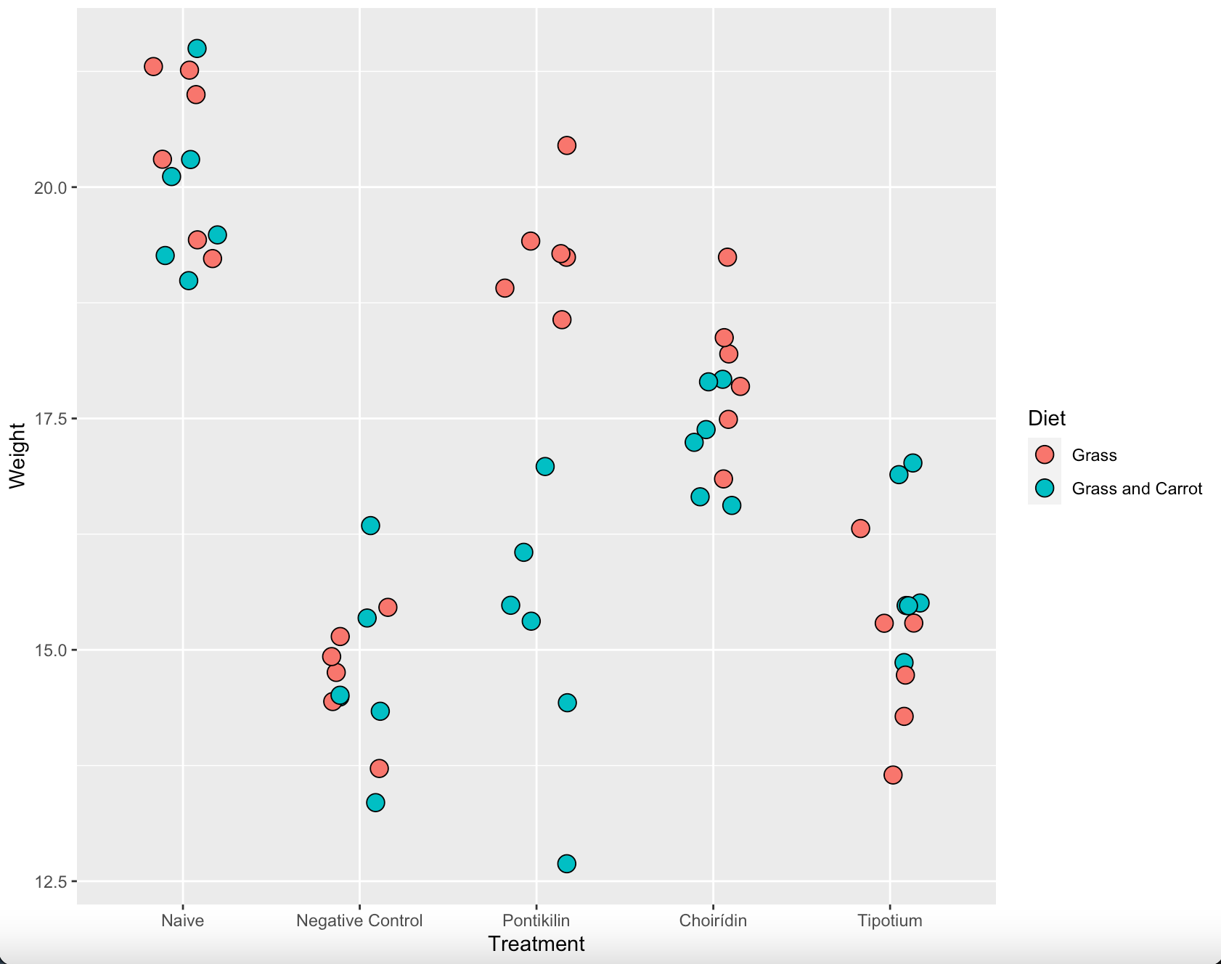

pig <- ggplot(dt1, mapping = aes(dt1$Treatment, y = dt1$Weight, fill = dt1$Diet))+

geom_jitter(width = 0.2, shape = 21, size = 4)+

labs(x = "Treatment", y = "Weight", fill = "Diet")

par(mfrow=c(1,1))

In this plot we see that the best treatment is Pontikilin for mice with grass diet. But as we know Guinea pig preferse grass and carrot. So the treatment with Choiridin is the best for our patient.

The same result we showed it boxplot version.

pig_bx <- ggplot(dt1, mapping = aes(dt1$Treatment, y = dt1$Weight, color = Diet))+

geom_boxplot()+

geom_point()

par(mfrow=c(1,1))

With ANOVA we checked if there are any differences between treatment groups.

summary( aov(Weight~T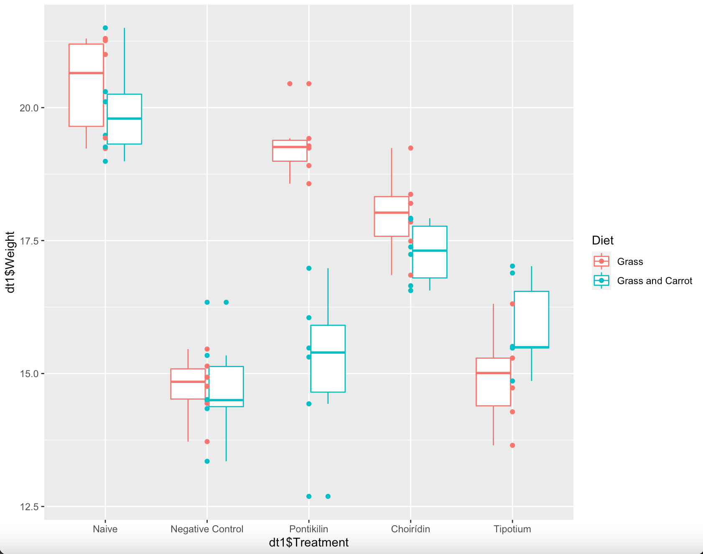reatment, data=dt1))

Df Sum Sq Mean Sq F value

Treatment 4 219.12 54.78 30.7

Residuals 55 98.14 1.78

Pr(>F)

Treatment 1.94e-13 ***

Residuals

---

Signif. codes:

0 ‘***’ 0.001 ‘**’ 0.01 ‘*’ 0.05 ‘.’

0.1 ‘ ’ 1

pontikilin_g <- t.test(dt1%>%filter(Treatment == "Pontikilin", Diet == "Grass")%>%select(Weight)%>%unlist,dt1%>%filter(Treatment == "Negative Control", Diet == "Grass")%>%select(Weight)%>%unlist)

choirídin_g <- t.test(dt1%>%filter(Treatment == "Choirídin", Diet == "Grass")%>%select(Weight)%>%unlist,dt1%>%filter(Treatment == "Negative Control", Diet == "Grass")%>%select(Weight)%>%unlist)

tipotium_g <- t.test(dt1%>%filter(Treatment == "Tipotium", Diet == "Grass")%>%select(Weight)%>%unlist,dt1%>%filter(Treatment == "Negative Control", Diet == "Grass")%>%select(Weight)%>%unlist)

pontikilin_gc <- t.test(dt1%>%filter(Treatment == "Pontikilin", Diet == "Grass and Carrot")%>%select(Weight)%>%unlist,dt1%>%filter(Treatment == "Negative Control", Diet == "Grass and Carrot")%>%select(Weight)%>%unlist)

choirídin_gc <- t.test(dt1%>%filter(Treatment == "Choirídin", Diet == "Grass and Carrot")%>%select(Weight)%>%unlist,dt1%>%filter(Treatment == "Negative Control", Diet == "Grass and Carrot")%>%select(Weight)%>%unlist)

tipotium_gc <- t.test(dt1%>%filter(Treatment == "Tipotium", Diet == "Grass and Carrot")%>%select(Weight)%>%unlist,dt1%>%filter(Treatment == "Negative Control", Diet == "Grass and Carrot")%>%select(Weight)%>%unlist)

tipotium_g <- tipotium_g$p.value

pontikilin_g <- pontikilin_g$p.value

choirídin_g <- choirídin_g$p.value

tipotium_gc <- tipotium_gc$p.value

pontikilin_gc <- pontikilin_gc$p.value

choirídin_gc <- choirídin_gc$p.value

grass <- c(pontikilin_g, choirídin_g, tipotium_g)

names(grass) <- c("pontikilin_g", "choirídin_g", "tipotium_g")

paste(names(grass)[grass==min(grass)],":",min(grass))

grass_carrot <-c(pontikilin_gc, choirídin_gc, tipotium_gc)

names(grass_carrot) <- c("pontikilin_gc", "choirídin_gc", "tipotium_gc")

paste(names(grass_carrot)[grass_carrot==min(grass_carrot)],":",min(grass_carrot))

After that with t.test we found the differences between two groups with p-values: "pontikilin_g : 1.71813405537607e-07», "choirídin_gc : 0.000697300795416417».

As we see, the pontikilin is more effective with grass feeded mice. But as our patient prefferes carrot reach diet, choiridin is more prefferable.